Version History

|  |  |  |  |  |  |
| --- | --- | --- | --- | --- | --- |
| Version # | Wrote by | Revision Date | Approved By | Approval Date | Outline |
| 1 |  |  |  |  |  |

Introduction

The Test Plan is designed to prescribe the scope, approach, resources, and schedule of all testing activities for the project Video Game: Voxelria. The plan is used to identify the items and features that is required to be tested, the testing types that is to be performed, the personnel responsible for testing, the resources and schedule required to complete testing, and the risks associated with the plan.

1. Test Strategy

1.1 Scope of Testing

1.1.1 Feature to be tested

All the feature of Video Game: Voxelria which were defined in FYP Proposal Report are need to be tested.

|  |  |  |
| --- | --- | --- |
| Module Name | Applicable Roles | Description |
| Voxel Terrain Generation Engine | Backend, Customer | Backend: The terrain successfully generated based on the set values of x, y, and z axis.  Customer: A customer can see, navigate, and interact with the terrain. |
| GUI Frontend | Customer | Customer: A Customer is able to navigate through the dashboard that consist of ‘Start’, ‘Settings’, and ‘Exit’ option. |
| Player Movement System | Customer | Customer: A customer is able to use the player movement, camera movement, and placing and destroying block. |
| Independent Terrain Boundary System | Backend,  Customer | Backend: The border successfully generated based on the set values of x, y, and z axis.  Customer: A customer cannot pass the boundary that has been set. |
| Tutorial Mode | Customer | Customer: A customer can play the tutorial mode which gives a brief tutorial on the basics of what a player can do within the game. |
| Modding | Customer | Customer: A customer can create and replace the texture pack of the game. (Texture for the Block) |
| Language | Customer | Customer: A customer is able to change the language between English, Malay, Chinese and Tamil. |

1.1.2 Feature not to be tested

These features are not to be tested because they are not included in the Project Features:-

* Background Music
* Sound Effects

1.2 Test Type

In the project Video Game: Voxelria, there are three types of testing that will be conducted.

* Unit Testing: Individual Software Modules are tested individually
* Integrated Testing: Individual Software Module are tested as a group
* User Acceptance Testing: The final system will be tested by customer

1.3 Risk and Issues

|  |  |
| --- | --- |
| Risk | Mitigation |
| Team members lack the required skills for C++ coding | Give trusted online videos related to C++ tutorial |
| The project schedule is short: cannot complete the testing on time | Set Test Priority for each test activity |

1.4 Test Logistics

1.4.1 Who will test?

Unit Testing: Developers (Muhammad Naqiuddin bin Amran@Amaran, Muhammad Danial bin Mohd Daud)

Integrated Testing: Testers (Imran Syafiq bin Abdul Rahman)

UAT: Customer

1.4.2 When will test occur?

The testing will commence once: -

* Software is available for Testing
* Test Specification is Created
* Test Environment is Built
* Enough Human Resource for Testing

2. Test Objective

The test objectives are to verify the functionality of the Video Game: Voxelria project. The project should focus on testing the: -

a. Block Generation

b. Terrain Generation

c. Border Generation

d. Player movement

e. Camera Movement

f. Placing and destroying block

g. Dashboard Menu

All of this can work as intended when the product reaches the player.

3. Test Criteria

3.1 Suspension Criteria

If the team members report that there are 38% of test cases failed, suspend testing until the development fixes all the failed cases.

3.1 Exit Criteria

Specifies the criteria that denote a successful completion of the test phase

* Run rate mandatory to be 100% unless a clear reason is given.
* Pass rate 80%, achieving the pass rate is mandatory.

4. Resource Planning

4.1 System Resource

|  |  |  |
| --- | --- | --- |
| No. | Resources | Descriptions |
| 1 | Laptop | A portable computer |

4.2 Human resource

|  |  |  |
| --- | --- | --- |
| No. | Member | Tasks |
| 1 | Test Manager | Mange the Whole Project  Define project directions  Acquire appropriate resources |
| 2 | Test | Identifying and describing appropriate test techniques/ tools/ automation architecture  Verify and assess test approach  Execute the tests, Log result, report the defect  Outsources members |
| 3 | Developer in test | Implement the test case, test program, test suite |

5. Test Environment

6. Schedule & Estimation

6.1 All project task and estimation

|  |  |  |
| --- | --- | --- |
| Task | Members | Estimate Effort |
| Create the test specification | Test Manager | 14 days |
| Perform test execution | Test Manager, Developer | 14 days |
| Test Report | Test Manager | 1 day |
| Test Delivery |  | 1 day |
| Total | | 30 days |

6.2 Schedule to complete these tasks

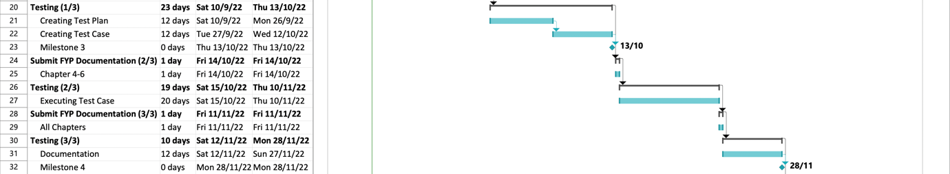

7. Test Deliverables

Test Deliverables are provided as below

7.1 Before testing phase

- Test Plans Document

- Test Cases Document

7.2 During the testing

- Test Trace-ability matrix

- Test data

7.3 After the testing cycle is over

- Test Results/Reports

- Defect Report

- Installation/ Test Procedures guidelines

- Release notes